***ROUTER ON A STICK***

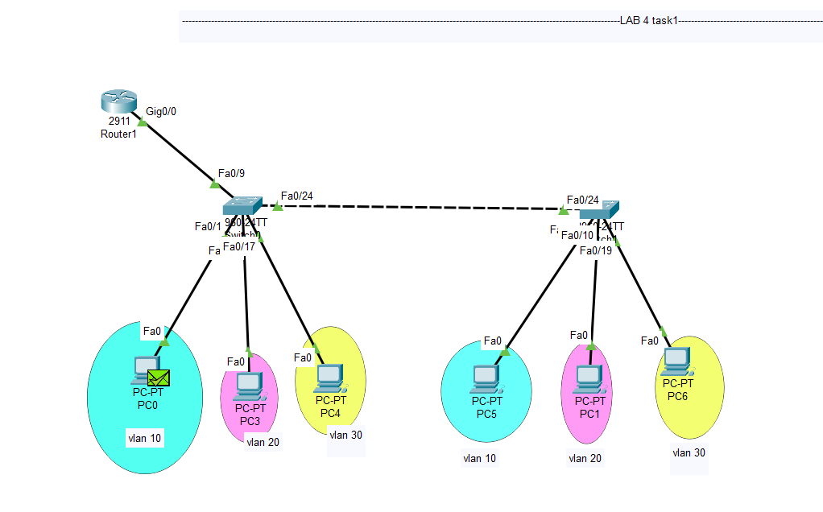

**INSTRUCTIONS:**

1. **first implement the vlan in both switches while doing that keep in mind that you need to keep open two trunk links in switch0 (for the upper implementation).**
2. **Then go to the router and configure sub interfaces as they will act as the default gateway for the vlans. CODE BELOW:**

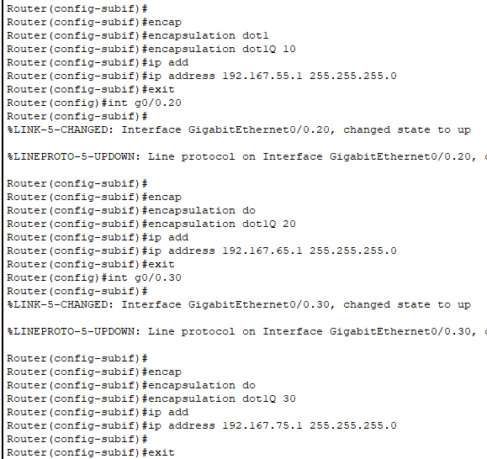

1. **Then set the status of the int g0/0 to no shut.**